Dorothy and Kansas
A Volume Problem
By Geoff Weilert,
Owings Mills High School
Owings Mills,MD

Dorothy misses all her friends from Oz. Back in the black and white Kansas landscape there are no dancing munchkins, no singing scarecrows, and life outside of the NCAA Basketball Tournament is pretty dull and boring, at least until the Stanley Cup Playoffs begin. She decides to return to Oz, but since “there is no place like home” or for those of us at Owings Mills High, it is “there is no place like OMH”, she decides to take Kansas with her.
The next tornado is scheduled for Friday afternoon. From her portable Doppler radar that she picked up at Radio Shack, she notices that the tornado is in the shape of a vertical parabola of revolution, that is 3.5 miles across at the top and 8000 feet high. Kansas is essentially a rectangle 400 miles long and 200 miles wide with a good rich midwestern topsoil of 6 inches.
A. Determine the volume of Kansas.
B. Determine the volume of the tornado.
C. Does Dorothy have enough space to take all of Kansas or must she be forced to say, “I guess we’re not in toto anymore Kansas?
Remember that no help is available from the scarecrow who didn’t have the brains for calculus, the tinman who didn’t have the heart to stick with it, and the lion who was to afraid to take calculus so took zoology instead.

Solution:
The parabola passes through point (0,0) and (1.75,50/33), the 8000 ft was converted into miles.
The equation is therefore:

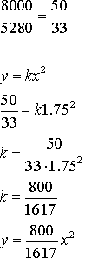

y = 800 x²
1617

The volume of Kansas is
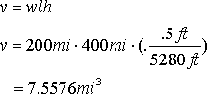

v=lwh
= 200 mi x 400 mi x (.5 ft/5280 ft)
= 7.576 cubic miles

Volume of the tornado
By disks
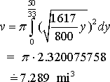

The tornado does not have enough room for both Kansas and Dorothy so maybe she should move to Delaware or Rhode Island or the only munchkins that she will see are at Dunkins Doughnuts.

