Mini Examination #2 A.P. Calculus Name __________________________________

I. Multiple Choice

_____ 1. Determine the differential dy of
(A) (B) (C) 15x – 10
(D) (E) None of the above

_____ 2. What is the instantaneous rate of change of at x = 2?
(A) 13 (B) 1 (C) 0 (D) (E) 2

_____ 3. Determine for the curve defined by
(A) (B) (C) (D) (E)

_____ 4.

(A) (B) (C) (D) (E) It is nonexistent

_____ 5. Water is draining at the rate of 48 cubic feet per minute from an inverted conical
tank whose diameter at its base is 40 feet and whose height is 60 feet. How fast is the
height of the water in the tank decreasing at the instant that the height is 48 feet?
(A) 3 ft/min (B) ft/min (C) ft/min (D) ft/min (E) ft/min

_____ 6. If , then

(A)
(B)
(C)
(D)
(E)

_____ 7. The normal line to the curve at the point (2, 2) has slope
(A) (B) (C) (D) 1 (E) 2

_____ 8. Evaluate the limit: =

(A) 0 (B) (C) (D) (E)

_____ 9. If then

(A) (B) (C)

(D) (E)

II. Free Response
SHOW ALL WORK ON YOUR OWN PAPER. Do NOT write on this test paper.

10. Determine the 38th derivative of .

11. Determine the second derivative of .

12. Draw the graph of the derivative of the function below:

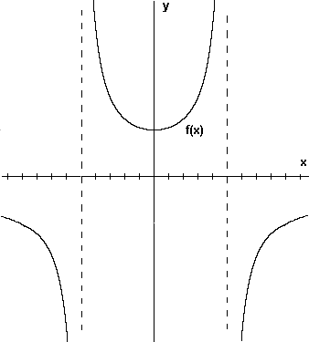

13. Given the parametric equations:
Determine the derivative

14. Evaluate the limit: =

15. Given

Evaluate

16. Determine the value of k if the graphs of and are tangent to
each other at a point in the first quadrant.

17. State and prove the derivative formula for .

18. Determine the derivative of .
SHOW ALL STEPS!

