Mini Examination #2 Limits and Derivatives Name ___________________________

I. Multiple Choice

_____ 1. Determine the differential dy of
(A) (B) (C) 15x – 10
(D) (E) None of the above

_____ 2. What is the average rate of change of over [-1, 4]?
(A) (B) 3 (C) 5 (D) 10 (E) 25

_____ 3. What is the slope of the curve defined by at the
point (1, 1) ?
(A) (B) (C) 0 (D) (E) It is undefined.

_____ 4.

(A) (B) (C) 0 (D) (E) It is nonexistent

_____ 5. The water level in a cylindrical barrel is falling at a rate of one inch per minute.
If the radius of the barrel is ten inches, what is the rate that water is leaving the
Barrel (in cubic inches per minute) when the Volume is 500 cubic inches?
(A) 1 (B) (C) 100 (D) 200 (E) 500

_____ 6.

(A)
(B)
(C)
(D)
(E)

_____ 7. The equation of the line tangent to at is

(A)
(B)
(C)
(D)
(E) None of the above

_____ 8. If
Then

(A) (B) (C) 2 (D) (E) The limit doe not exist

_____ 9. If , then

(A) (B) (C)

(D) (E)

II. Free Response
SHOW ALL WORK ON YOUR OWN PAPER. Do NOT write on this test paper.

10. Determine the 35th derivative of .

11. Determine the second derivative of .

12. Draw the graph of the derivative of the function below:

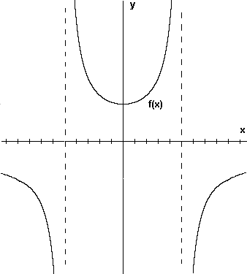

13. Given the parametric equations:
Determine the derivative

14. Evaluate the limit: =

15. Given

Evaluate

16. Determine the value of k if the graphs of and are tangent
to each other at a point in the second quadrant.

17. State and prove the derivative formula for .

18. Determine the derivative of .
SHOW ALL STEPS!

