A. P. Calculus First Semester Examination Mr. Pleacher Name ___________________

A calculator is NOT allowed on this section of the Exam.

I. Multiple Choice

_____ 1. If , which of the following is an asymptote to the graph of f ?
(A) (B) (C) (D) (E)

_____ 2. If , then a =
(A) 2 (B) 4 (C) 8 (D) 16 (E) 32

_____ 3. The area of a circle is given by . Assuming that the radius is changing, the
formula for the instantaneous rate of change of A with respect to r is:
(A) (B) 0 (C) (D) (E)

_____ 4. If , then
(A) (B) (C) (D) (E)

_____ 5. Let . What is the range of ?
(A) (B) (C)
(D) (E)

_____ 6. Evaluate
(A) (B) (C) 0 (D) 1 (E)

_____ 7. is equivalent to
(A) (B) (C)
(D) (E)

_____ 8. Evaluate
(A) (B) (C) (D) 3 (E) 9

_____ 9. The set of all points where t is a real number is the graph of:
(A) (B) (C) (D) (E)

_____ 10. If What is the maximum value for y?
(A) 25 (B) (C) 28 (D) 29 (E) 18

_____ 11. Which of the following is a point of discontinuity for ?
(A) (B) 2 (C) 0 (D) (E)

_____ 12.

(A) (B) 1 (C) 0 (D) (E)

_____ 13. The graph of has a point of inflection at x =
(A) 0 (B) (C) (D) (E) None of these

_____ 14. Determine the exact value of
(A) 0 (B) radians (C) (D) 60 degrees (E) None of these

_____ 15. If , then the inverse function
(A) (B) (C) (D) (E) x

_____ 16. If over the same interval, which of the following
statements is true for over that interval?
(A) is increasing and concave up
(B) is increasing and concave down
(C) is decreasing and concave up
(D) is decreasing and concave down
(E) None of the statements are true

_____ 17. Given a function f, how many of the following statements are true?
(i) If , then the graph of is concave upward at .
(ii) If , then the graph of is concave downward at .
(iii) If , then is a relative maximum.
(iv) If , then .

(A) 0 (B) 1 (C) 2 (D) 3 (E) 4

_____ 18. A square piece of tin has 10 inches on a side. An open box is formed by cutting out
equal square pieces from the four corners and then bending up the sides. Determine
the length of the side of the squares that will result in the maximum volume of the
box.
(A) 1 inch (B) inches (C) inches (D) 5 inches
(E) None of the above

_____ 20. Which of the following statements is true?

--------------------------------------------------------------------------------------------------------------------

II. Free Response

21. Prove the following derivative formula:
Given:
Prove:

22. Write out the complete definition of the derivative.

23. Graph the function on the axes below:

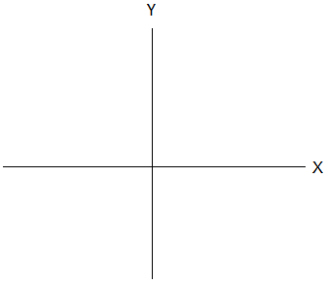

24. Graph the greatest integer function on the axes below:

25. Graph the derivative of on the axes below:

__________ 26. Evaluate the limit:

__________ 27. Evaluate the limit:

__________ 28. Evaluate the limit:

__________ 29. Evaluate the limit:

__________ 30. Evaluate the limit:

__________ 31. Determine the differential dy, given that .

__________ 32. Determine the derivative of .

__________ 33. Determine the inverse function of .

__________ 34. Determine

35-36. Given the equation , determine the following:

First Derivative: _________________________________________________________

Increasing on: _________________________________________________________

Decreasing on: _________________________________________________________

Relative Maximum at: _____________________________________________________

Relative Minimum at: _____________________________________________________

Second Derivative: _______________________________________________________

Concave Up on: _______________________________________________________

Concave Down on: _____________________________________________________

Point of Inflection at: ____________________________________________________

37. Sketch the graph of the curve

38. Given the graph of the curve f(x), draw the graph of f’(x) on the axes below:

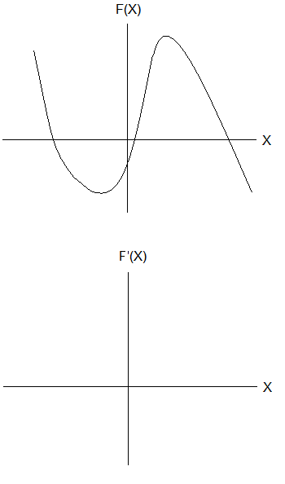

39. Sketch $y=f(x)$, given that
$\begin{aligned}f(1)=−2 \\ f\text{ \backslash ( x \backslash ) <0``````` ital }for\text{`x<1\} \{\} \# size 12\{f}(x)>0 \text{for} x>1\end{aligned}$

40. Prove the following derivative formula:
Given:
Prove:

