Test A.P. Calculus Sections 3.1 – 3.5 Name _____________________________________

I. Multiple Choice

_____ 1. Determine if

_____ 2. Given y = f(x) = 2x³, determine the average rate of change of y with respect to x over
the interval [1, 3].
(A) 52 (B) -52 (C) -26 (D) 26 (E) 0

_____ 3. An object moves in a straight line so that after t seconds its distance in mm from its
original position is given by s = t ² + t. Its instantaneous velocity at t = 3 seconds is
(A) 18 mm (B) 19 mm (C) 12 mm (D) 7 mm (E) 0 mm

_____ 4.
(A) (B) (C) (D) (E)

_____ 5. If , then

(A) 0 (B) 6u (C) 6x – 93 (D) 6 (E) 6x

_____ 6. If , then
(A) (B) 0 (C) (D) -1 (E)

_____ 7. Given Determine
(A) (B) (C) (D) (E)

_____ 8. The volume of a sphere is given by the formula .
Assuming that the radius is changing, the formula for the instantaneous rate of
change of V with respect to r is:
(A) (B) (C) (D) (E)
_____ 9. If
(A) -4 (B) -3 (C) 4 (D) 3 (E) 0

_____ 10. Determine the value of k so that the line is tangent to the curve .
(A) 2 (B) 0 (C) -1 (D) 1 (E) None of these answers

II. Free Response
Do ALL work on your own paper.

11. Sketch the graph of the derivative of the function whose graph is shown below:

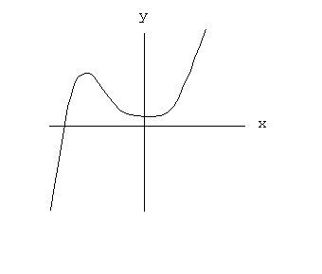
12. Given . Determine given that and .

13. Determine if .

14. If , Determine .

15. Determine the equation of the line tangent to the graph of at the point where
x = -3 if and

16 - 17. Given the function .

16. Determine

17. Write the equation of the line tangent to at the point where x = -1.

18. Given , Determine .

19. Write out a complete definition of the derivative.

20. Given , use the definition of the derivative to determine .

21. Extra Credit:
A small water balloon was projected vertically upward by a disgruntled calculus student with an initial velocity of 160 ft/sec. It reaches an elevation of feet at the end
of t seconds. How fast is it traveling at t = 3 seconds? When would it hit the calculus teacher who just happens to be walking by a few seconds later and who is 6 feet tall?

