Test Chapter 5 Name __________________

I. Multiple Choice

_____ 1. The largest interval on which is
increasing is
(A) (B) (C)
(D) (E)

_____ 2. has an absolute maximum on of
(A) 6 (B) 0 (C) 11 (D) 2 (E) 4

_____ 3. Determine the value of c that satisfies Rolle’s
Theorem for the function on .
(A) -1 (B) 0 (C) 1 (D) 0.5 (E) –0.5

_____ 4. Determine the value of c that satisfies the Mean Value
Theorem for on .
(A) 0 (B) (C) (D) (E)

5-6. Use the graph of shown in the figure to answer the
questions below.

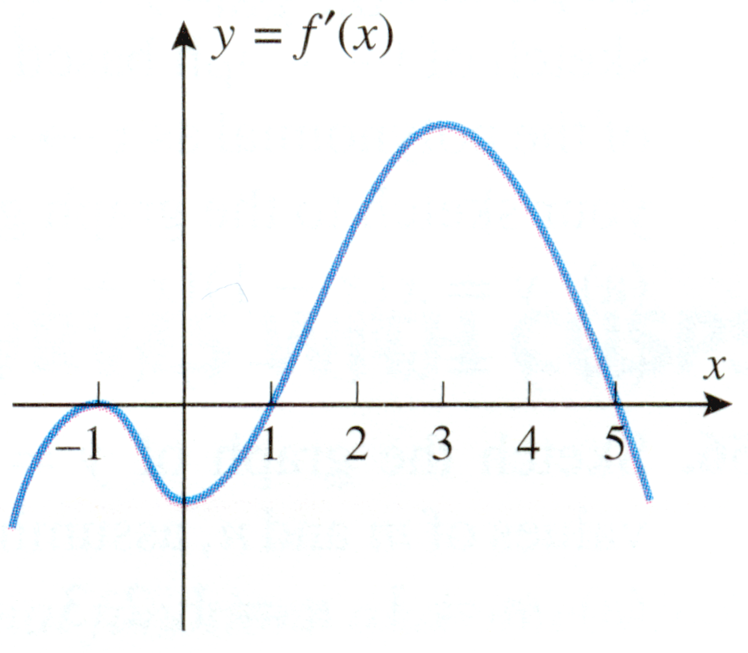

_____ 5. Determine the x-coordinates where has a relative
minima.
(A) (B) (C)
(D) (E)

_____ 6. Determine the x-coordinates where has a point of
inflection.
(A) (B) (C)
(D) (E)

_____ 7. is concave down on
(A) (B) (C) (D) nowhere
(E)

_____ 8. has
(A) a relative maximum at x = -4
(B) a relative minimum at x = -4
(C) a relative maximum at x = 4
(D) a relative minimum at x = 4
(E) a relative minimum at x = 0

II. Free Response

9 - 10. Give the following information for the function:

Derivative: __________________________________

Increasing on ( ___ , ___ ) and ( ___ , ___ )

Decreasing on ( ___ , ___ )

Relative Minimum at ( ___ , ___ )

Second Derivative: ___________________________

Concave Up on ( ___ , ___ ) and ( ___ , ___ )

Concave Down on ( ___ , ___ )

Points of Inflection at( ___ , ___ ) and ( ___ , ___ )

11. Sketch the function which is
increasing on (, 0) and (2, ),
decreasing on (0, 2),
concave up on (1, ),
concave down on (, 1),
and has a
relative maximum at (0, 4),
relative minimum at (2, 0),
point of inflection at (1, 1).

12. Sketch a curve that satisfies the following conditions:
13. Sketch y = f(x), given that

14. Determine the constant k so that the function
will have a point of inflection at x = 1.

15. The equation has one real root. Approximate
it by Newton's method. Let x₁ = 1; then determine x₂ and
x₃.

16. The height of an object at a given time t is given by the
formula where is the initial position,
is the initial velocity, and g is the acceleration due
to gravity (use 32 for the value of g).

If an object is launched vertically upward from an
initial height of 10 feet with an initial
speed of 64 ft/sec, use calculus to determine how high
the object will rise.

17 - 19. Set up each of the following, but do not solve them.
You may stop when you have expressed the quantity
you are trying to maximize or minimize in terms of
only one variable. When you have finished setting up
all three problems, go back and completely solve one
of them.

17. Determine the volume of the largest right circular
cylinder that can be inscribed in a right circular
cone whose radius is 3 feet and altitude is 6 feet.

18. A tank with a rectangular base and rectangular sides is
to be open at the top. It is to be constructed so that
its width is 4 meters and its volume is 36 cubic meters.
If building the tank costs $10 per square meter for the
base and $5 per square meter for the sides, what is the
cost of the least expensive tank?

19. A cylindrical can is to hold 20ח cubic meters. The
material for the top and bottom costs $10 per square
meter and material for the side costs $8 per square
meter. Find the radius and height of the most
economical can.

20. In the diagram below, show how you would hit the golf
ball from T so that it would go into the hole at H.

