Test A. P. Calculus Sections 6.1 – 6.6 Name _______________________________

1 – 6. Multiple Choice

_____ 4. Suppose that you approximate the area under
on the domain with n = 4 subintervals, using right-hand endpoints.
The set of x-values you need to use are:

7 – 16. Free Response SHOW ALL WORK on your own paper – Do NOT write on the
test paper for any problems in this section except for #16.

8. Determine the exact area between the curve and the x-axis over the interval
. Use circumscribed rectangles (right-hand endpoints in this problem) and
apply a limit.

You will need to apply one of the following:

9. Determine the area between the curve and the x-axis
from .

10. Evaluate

11. Evaluate

12. Evaluate =

13. Evaluate =
You must show ALL WORK, and you must use calculus to solve!

14. Prove by induction:

15. Solve the differential equation

16. Draw a slope field for the differential equation

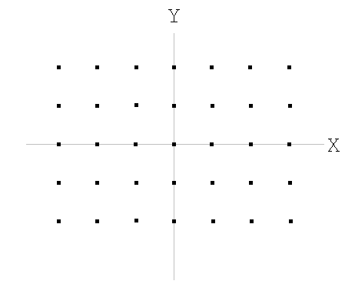

Extra Credit (5 points) Evaluate

