Precalculus 1st Semester Examination Chapters 4, 5 Name ____________________

Place all answers in the spaces provided.

I. Multiple Choice

_____ 1. A function having the period 180˚ is:

(A) y = sin(2x) (B) y = ½ sin(x) (C) y = sin(½ x) (D) y = 2sin (x)

_____ 2. Simplify

(A) csc(θ) (B) sin(θ) (C) cot(θ) (D) cos²θ

_____ 3. Simplify the following:
(A) tan(θ) (B) sin(θ) (C) -tan(θ) (D) -cos(θ)

_____ 4. The horizontal displacement of is:
(A) 2 (B) 3 (C) 4 (D)

_____ 5. The expression sin(2θ) cos(θ) – cos(2θ) sin(θ) is equivalent to:
(A) sin(3 θ) (B) cos(3 θ) (C) sin(θ) (D) cos(θ)

_____ 6. sin (90˚ - x) is equal to:
(A) sin(x) (B) cos(x) (C) tan(x)



_____ 7. If and , then =
(A) (B) (C) (D)

_____ 8. The amplitude of y = 2 + 3 sin 5(x – π) is:
(A) 2 (B) π (C) 3 (D)

_____ 9. If , then sin(x) =
(A) (B) (C) (D)

_____ 10. The period of the function y = sin(x) is:
(A) 2 (B) π (C) 6 (D) 2π

II. Graph the following on the axes provided:

11. Graph y = 2 cos(4x)



12. Graph y = sin(x + 45˚) for 0˚ ≤ x < 360˚

13. Graph y = tan(x) for 0˚ ≤ x < 360˚

14. Graph y = sec(x) for 0 ≤ x < 2π

15. Graph y = 1 + 2cos 2(x - 90˚) for 0˚ ≤ x < 360˚

III. Matching

_____ 16. A. 0

_____ 17. B. 1

_____ 18. csc(150˚) C. undefined

_____ 19. D. –1

_____ 20. cot(330˚) E.

_____ 21. tan(90˚) F.

_____ 22. sin(180˚) G. ½

_____ 23. H. 2

_____ 24. cos(-5π) I.

_____ 25. J.

K.

L. None of these

IV. Solve the following equations:

__________ 26.

__________ 27. Solve

__________ 28. Solve

__________ 29. Solve 2 cos²x – 5cos(x) + 2 = 0 for 0˚ ≤ x < 360˚

__________ 30. Solve for 0˚ ≤ θ < 360˚

__________ 31. Solve 2 sin²x – 1 = 0 for 0˚ ≤ x < 360˚

V. Prove the following identities:

32. Prove

33. Prove

34. Prove

35. Prove

36. Prove

37. Prove

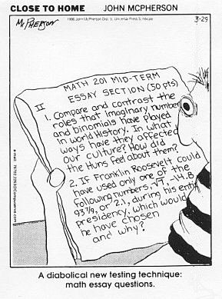
VI. Miscellaneous Problems

__________ 38. Convert 80˚ to radians

__________ 39. Convert to degrees

__________ 40. Determine the value of sec (-2345˚)

__________ 41. Determine the value of cot(85˚)

__________ 42. Determine the value of cos(.82)

__________ 43. Simplify

__________ 44. Which trig functions are positive in the fourth quadrant?

__________ 45. In which quadrants is the tangent negative?

__________ 46. Determine the quadrant in which the terminal side of an
angle of 395˚ lies.

__________ 47. Given an angle of 290˚, what is the measure of the reference angle?

__________ 48. Determine the exact value of

__________ 49. Graph the following function on the axes below:

__________ 50. Your cat is on a tree branch 12 feet above the ground. If your ladder is
20 feet long, at what angle must it be placed against the tree (so that
the top of the ladder is 12 feet above the ground)?

__________ 51. Commercial airliners fly at an altitude of about 3000 feet. If the pilot
wants to land at an angle of 3˚ with the ground, at what horizontal
distance from the airport must she start descending?

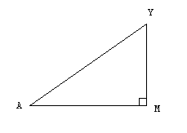
__________ 52. Find the length of segment
MY in the diagram at the
right, given that
and
AY = 15 inches.

___________ 53. What is the domain of y = cos (x) ?

___________ 54. What is the range of y= Arctan (x) ?

___________ 55. Determine the exact value of sin(θ) if θ is in standard
position and its terminal side contains the point (3, -2).

___________ 56. A ship is 80 miles south and 20 miles east of port. If the captain
wants to travel directly to port, what bearing should be taken?
___________ 57. Determine the exact value of:

___________ 58. Express cos(3x) in terms of cos(x) and sin(x)

___________ 59. Determine the least positive value of θ such that:

___________ 60. If and , then tan(x) =

__________ 61. Extra Credit: Express the Arcsec (x) in terms of the ArcTangent

