Precalculus Final Examination Name _________________________

I. Definitions

1. Write the definition for a relation.

____________________________________________________________

____________________________________________________________

____________________________________________________________

2. What is the definition of the period of a trigonometric function?

____________________________________________________________

3. Write the definition of the sine function.

____________________________________________________________

____________________________________________________________

4. Write the general equation for an exponential function.

____________________________________________________________

5. Write the definition of the median of a set of data.

____________________________________________________________

6. Write the general form of a sinusoidal function.

____________________________________________________________

II. Sketch the graphs of each of the following in the spaces provided.

7. A normal distribution.

__________________________________

8. The cosecant function.

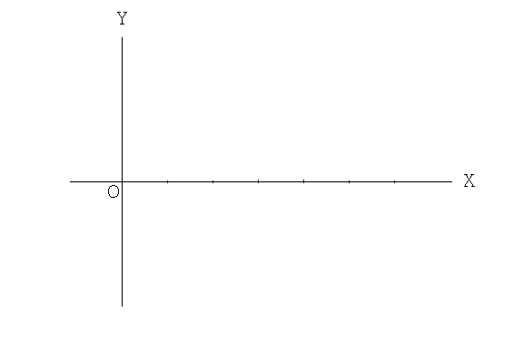

9. Graph the following points on the polar coordinate graph paper below:

A (-4, -45˚)
B (5, 300˚)
C (4, -150˚)
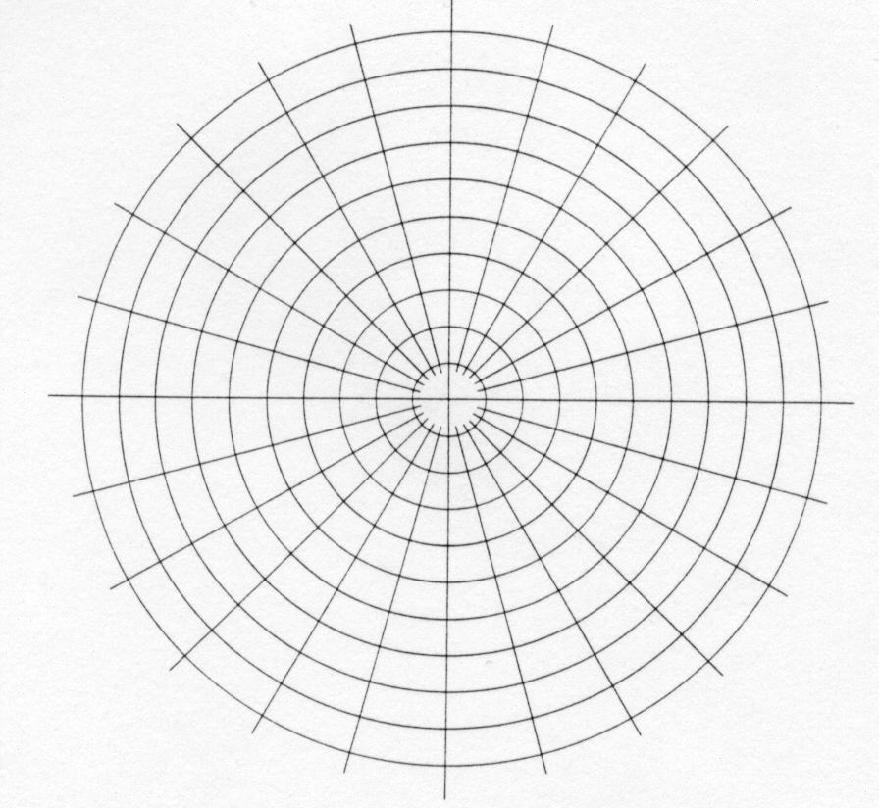
10. The tangent function.
11. y = 3 sin(2x)
12.
13. A rose curve with three petals.

14. Graph the following on the complex number plane:
(A) 2 - 3i (B) -3 + 2i (C) -1 - 3i
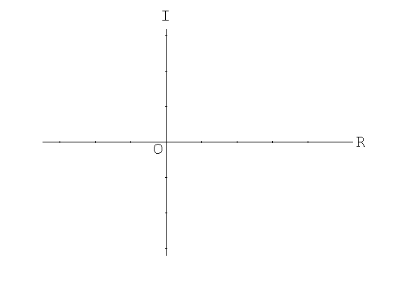

III. Different kinds of functions have different properties.

15. State the trigonometric identity involving the squares of sines and cosines.

____________________________________________________________

16. State the double angle property for cos (2x).

____________________________________________________________

17. State the property of the logarithm of the quotient of two numbers.

____________________________________________________________

18. State the Law of Cosines.

____________________________________________________________

19. State the probability that event A occurs and that event B occurs.

____________________________________________________________

20. State Heron's formula.

____________________________________________________________

IV. Proofs are essential in mathematics.

21. Prove by mathematical induction that the sum of the first n positive odd
integers is n².

Prove: 1 + 3 + 5 + … + (2n – 1) = n²

22. Prove the following identity:

23. Prove the following identity:

23. Prove the following identity:

V. The word inverse is an important concept in mathematics.

_______________ 24. Determine the additive inverse of 4.

_______________ 25. Determine the inverse function of y = 3x + 12

_______________ 26. Determine the inverse tangent of –1
(that is, evaluate Tan⁻¹(-1) )

VI. Multiple Choice

__________ 27. A geometric series has t₁ = 7 and r = 3. Determine the value of the
fifteenth term.

(A) 472,969 (C) 14,348,907
(B) 33,480,783 (D) 1.0044 x 10⁸

__________ 28. The number 818 is a term in the arithmetic sequence
19, 36, 53, … Which term is it?

(A) 53 (B) 47 (C) 48 (D) 43

__________ 29. The binomial (h – j) ²⁰ is expanded as a binomial series.
The term with j⁷ is

(A) 77520 h¹³ j⁷ (B) 125970 h¹³ j⁷
(C) -77520 h¹³ j⁷ (D) -125970 h¹³ j⁷

__________ 30. If and , determine in terms of its
components.
(A) (B) (C)
(D) (E) None of these

__________ 31. Rewrite 7 – 2i in trigonometric form (Polar form).
(A) (B)
(C) (D)
(E) None of these
__________ 32. A function having the period π is

(A) (B)

(C) (D)

__________ 33. Simplify:

(A) (B) (C) (D)

__________ 34. If and then

(A) (B) (C) (D)

VII. Short Answer

__________ 35. Solve for x:

__________ 36. Solve for θ: for

__________ 37. Solve for θ: for

__________ 38. Convert radians to degrees.

__________ 39. Determine the value of

__________ 40. Which trigonometric functions are positive in the fourth quadrant?

__________ 41. In which quadrants is the cosecant negative?

__________ 42. A window is 23 feet above the ground. What angle will a 27-foot
ladder make with the house when it is touched to the bottom of the
window?

__________ 43. Determine the measure of the smallest angle in a 5-12-13 right triangle.

VIII. Multiple Choice

__________ 44. If is an acute angle, express sin in terms of cos.

(A) (B)
(C) (D)

__________ 45. If sin(B) = cos(B), what is the measure of ?

(A) (B) (C) (D)

__________ 46. In , side a = 3 inches, , and ;
what is the length of side b ?

(A) 0.6 (B) 6 (C) 1.5 (D) 15

__________ 47. The expression is equivalent to

(A) (C)
(B) (D)

__________ 48. The inverse of is

(A) (B) (C) (D)

__________ 49. In , if side a = 8, side b = 9, and side c = 10, what is the
measure of ?

(A) (B) (C) (D)

__________ 50. Given with side a = 91.6 inches, side c = 24.19 inches, and
= 37˚, Determine the area of the triangle.
A) 1107.9 square inches B) 1333.5 square inches
C) 1769.6 square inches D) 666.8 square inches
E) None of these
__________ 51. In a baseball park, the distance from home plate to a point A in
straightaway centerfield is 400 feet. Determine the distance from A to
first base. (Straightaway centerfield is an extension of the line drawn
from home plate through second base. The distance between
consecutive bases is 90 feet).

(A) 66.2 feet (B) 135 feet (C) 342 feet (D) 378 feet

__________ 52. If then x =

(A) 2 (B) -2 (C) - (D)

__________ 53. Determine the value of

(A) 1 (B) -i (C) i (D) -1

__________ 54. Determine the resultant of the two given displacements below:

8 units at a bearing of followed by 6 units along a bearing of

(A) 7.2 units at a bearing of 136
(B) 51.9 units at a bearing of 46
(C) 7.2 units at a bearing of 46
(D) Can not be determined
(E) None of the above

__________ 55. Simplify

(A) (B) (C) (D)

__________ 56. In PEG, p = 6 cm, e = 7 cm, and g = 11 cm. Then mG =
A) 115.3˚ B) 98.6˚ C) 64.7˚ D) 18.27˚
E) Not possible (no such triangle)

__________ 57. Compute the number of combinations of 8 items taken 3 at a time.

(A) 56 (B) 336 (C) 40,320 (D) 6

IX. Problems (Short Answer)

__________ 58. Compute

__________ 59. If a card is drawn at random from a standard deck of cards,
calculate the probability of drawing a diamond.

__________ 60. In how many ways could you arrange 4 books on a shelf if there are 9
books from which to choose?

__________ 61. There are 9 boys and 4 girls on the Handley golf team. The coach
selects a group of 5 at random. What is the probability that the group
consists of 3 boys and 3 girls?

62 – 64. Handley's Softball team, Boys' Track team, and Girls' Tennis team all play on
Saturday. The probability that the track team will win is 0.6; the probability
that the softball team will win is 0.5; and the probability that the tennis team
will win is 0.8.

__________ 62. What is the probability that all three will win?

__________ 63. What is the probability that all three will lose?

__________ 64. What is the probability that all at least one of them will win?

__________ 65. On the mall at Apple Blossom, you were stunned to find your
Precalculus teacher operating a table with the following game:
You pay $1.00 and then pick a card at random from a standard
deck of 52 cards.
If the card is an ace, you win $4.00.
If the card is a face card, you win $2.00.
If the card is anything else, you win nothing.
What is your mathematical expectation?

__________ 66. Mr. P has 5 sport jackets, 5 pairs of trousers, and 310 hideous ties.
How many different outfits (1 tie, 1 jacket, and 1 pair of pants) could
he choose from if he selects a jacket, a tie, and a pair of pants at
random?

__________ 67. Winchester's favorite Elvis restaurant, Red, Hot , and Blue, offers three
types of ribs (Sweet Ribs, Dry Ribs, and Wet Ribs) and four Memphis-
style sandwiches (Pulled Pork, Pulled Chicken, Beef Brisket, and
Ribwich Combo). In how many different ways can you select one of
the Ribs meals OR one of the sandwiches?

68 –73. Given the following data:

x Frequency
3 9
4 8
5 6
6 3
7 4

(histogram) 68. Plot a histogram of the frequency distribution.

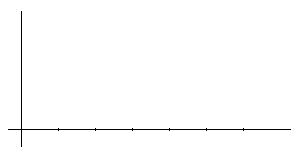

__________ 69. Determine the mean for the set of data.

__________ 70. Determine the median for the set of data.

__________ 71. Determine the mode for the set of data.

__________ 72. Determine the variance for the set of data.

__________ 73. Determine the standard deviation for the set of data.

74 – 77. In 2001, 1,276,320 students took the SAT. The mean for the math SAT
was 514 with a standard deviation of 113. Suppose that Matt E. Matics made a
score of 640.

__________ 74. How many standard deviations is Matt's score above the mean?

__________ 75. What percent of the students made below Matt's score of 640?

__________ 76. How many of the 1,276,320 students scored higher than Matt?

__________ 77. What percent of the students scored between 490 and 680 ?

__________ 78. Transform the following to Cartesian coordinates and simplify.

__________ 79. Transform the following to polar coordinates:

y = x²

__________ 80. Transform the parametric equations to a Cartesian equation by
eliminating the parameter.

x = 2t – 1
y = 3t + 1

