Precalculus Test 1 Sections 4.1 and 4.3 Name _________________________

SHOW ALL WORK!

I. Multiple Choice

__________ 1. Determine the quadrant in which the terminal side of an
angle of 215º lies.
(A) I (B) II (C) III (D) IV
(E) The terminal side lies on one of the axes

_________ 2. Convert 25º to radians.
(A) (B) (C) (D) (E) None of these

_________ 3. Convert radians to degrees.
(A) 0.0329º (B) 108º (C) 216º (D) 54º (E) None of these

_________ 4. Determine which angle is coterminal to .
(A) (B) (C) (D) Both A and C
(E) None of these

_________ 5. Determine which of the following angles is supplementary to .
(A) (B) (C) (D) (E) None of these

_________ 6. Simplify completely:
(A) (B) (C) (D) (E) None of these

_________ 7. Determine the tan 30˚ by constructing an appropriate triangle:
(A) (B) (C) (D) (E) None of these

_________ 8. Use a calculator to determine the cos (33˚):
(A) -.0133 (B) .8387 (C) .5446 (D) 1.5398 (E) None of these

_________ 9. Use a calculator to determine the csc(1.32)
(A) 2.0132 (B) 1.0323 (C) 0.0230 (D) 0.6872 (E) None of these

_________ 10. Given that sec θ = 5, determine the exact value of csc (90° - θ):
(A) (B) 5 (C) (D) (E) None of these

II. Free Response (Do on your own paper showing all work)

11. A bicycle wheel with an 18 inch diameter rotates 100˚. What distance has the bicycle
traveled?

12. Convert 178.463° to degrees, minutes, and seconds.

13. Given a right triangle where and AB = 7 inches and
BC = 4 inches. Determine the value of cot .

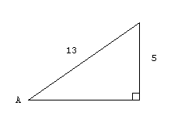
14. In the diagram at the right, determine the
exact values of the six trigonometric
ratios:

sin A =
cos A =
tan A =
cot A =
sec A =
csc A =

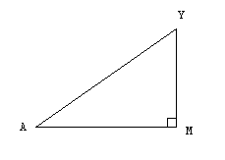
15. Find the length of segment MA in the
diagram at the right, given that
and AY = 12 inches.
(You will need a calculator)

16. Determine the exact value of cos(45˚) by constructing an appropriate triangle.

